Practical – 4

Definition: This practical involves cleaning, transforming, and analysing electric vehicle datasets in Power BI to derive insights about sales, penetration rates, and growth trends. The process includes data preparation, calculated fields, and interactive visualizations to explore EV adoption, state-wise performance, and manufacturer contributions.
Learning Outcome: Learned how to import EV sales datasets into Power BI, clean and transform data using Power Query Editor, create calculated measures, and build dashboards. Gained skills in analysing EV sales, penetration rates, CAGR trends, and manufacturer market share while applying intermediate and advanced Power BI techniques like KPI cards, maps, and trend analysis.
Required Tool: Power BI Desktop & Power Query Editor
Working: The dataset was imported into Power BI and prepared in Power Query Editor. Cleaning included removing blanks and duplicates, dropping unnecessary columns, handling missing values, and standardizing text fields. Calculated measures like Penetration Rate, CAGR, and Weighted Growth were created to measure EV performance and adoption. The cleaned data was then structured for dashboard building to answer questions ranging from total EV sales to growth comparisons across states and manufacturers.
Dataset Overview: The dataset contains EV sales details such as State, Maker, Vehicle Category, Fiscal Year, Electric Vehicles Sold, and Total Vehicles Sold. These fields allow analysis of EV adoption trends, category-wise distribution, market penetration, and manufacturer performance.
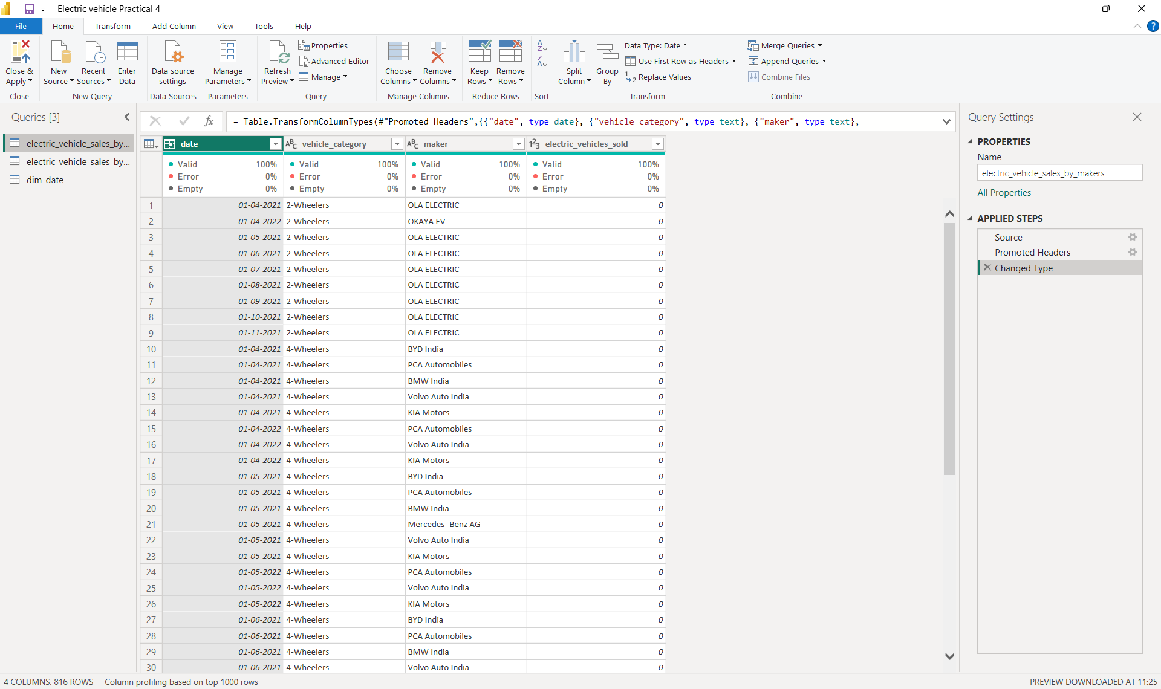

Step 1: Loading Data in Power BI Desktop: The EV sales dataset was imported using Get Data. Once loaded, the Model View was checked to confirm the structure and relationships between the EV sales tables (state-wise and maker-wise) and the Date Dimension table.
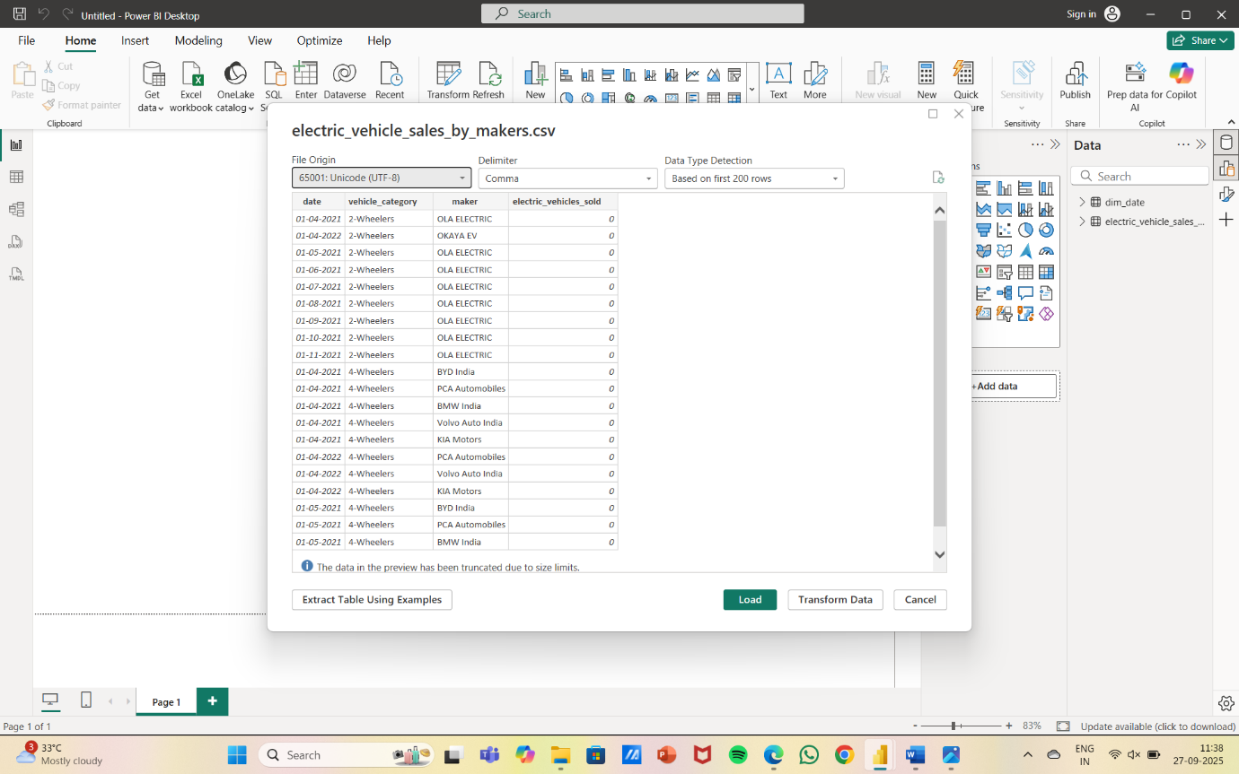

Step 2: Data Modelling: In Power BI, relationships were established between the Date Dimension table and the EV sales tables on the fiscal year/date column. The EV State table used State as a categorical key, and the Maker table used Maker as a categorical key for aggregations. This ensured accurate data aggregation, consistency across visuals, and enabled dynamic interaction between dashboard elements for deeper analysis.
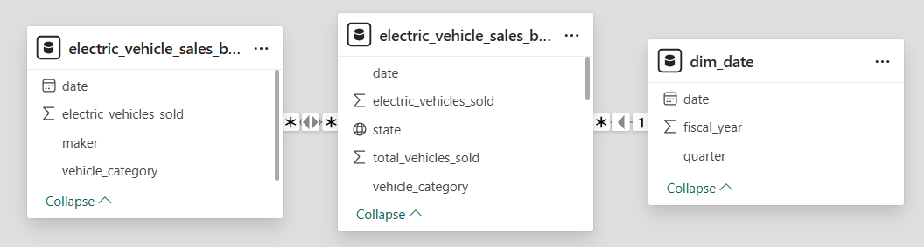

Step 3: Cleaning & Transforming Data: The dataset was thoroughly cleaned and prepared for analysis by removing blank and duplicate rows to ensure accuracy and dropping irrelevant columns. Missing values in fields like vehicle category or sales were handled, and categorical data such as state and maker names were standardized for consistency. Additionally, calculated measures were created to enhance insights, including Penetration Rate (EVs ÷ Total Vehicles), Penetration Change (YoY difference), and CAGR (compound annual growth rate of EV sales). After cleaning and transformation, the data was loaded back into Power BI by clicking on Close & Apply.
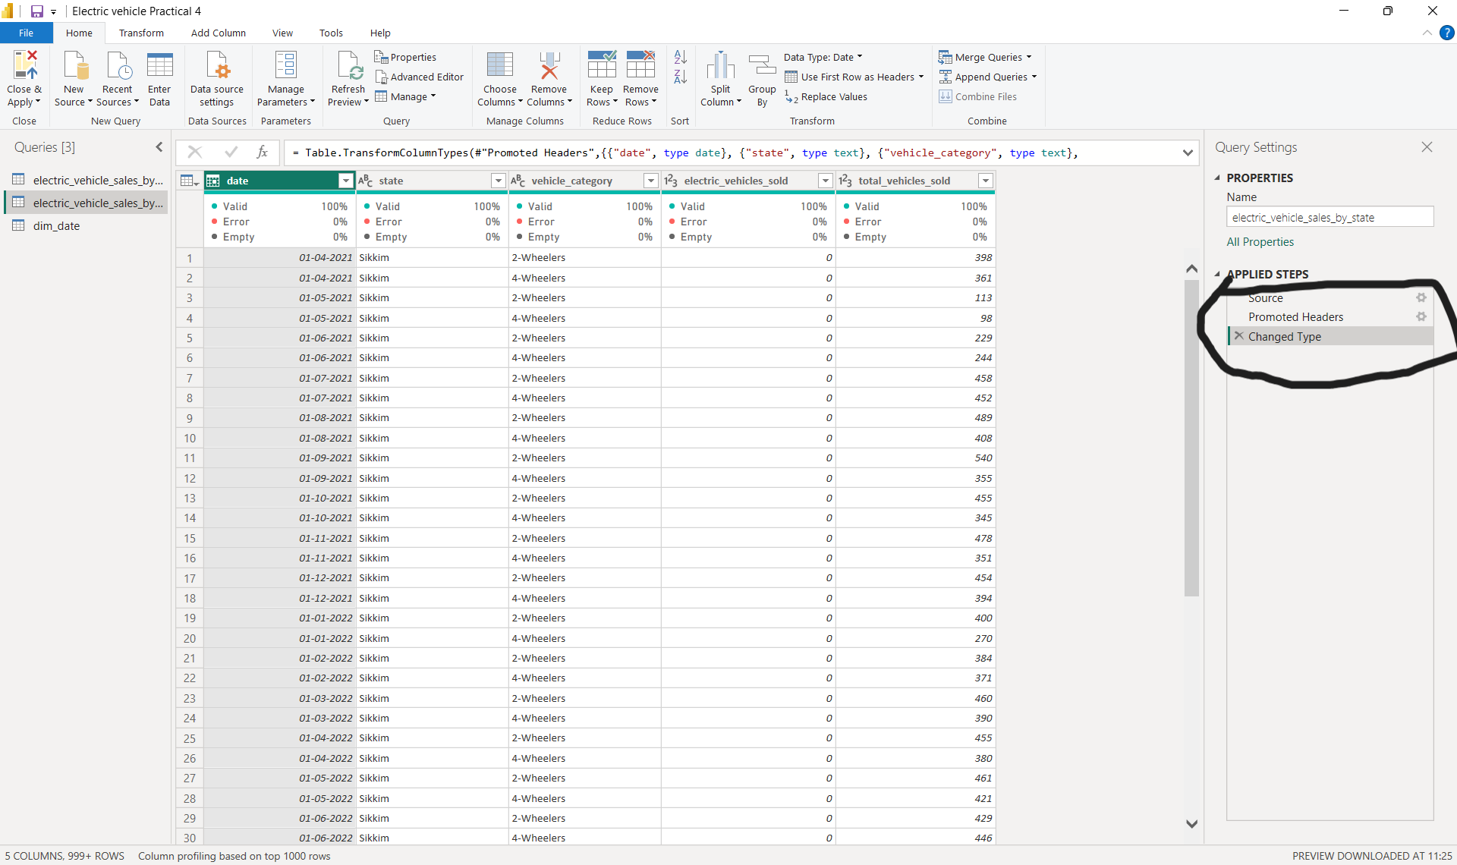

Step 4: Building Visualisations: Interactive dashboards were built in Power BI using charts, maps, and KPI cards to answer primary and advanced research questions. Visuals highlighted top and bottom makers, penetration rates, CAGR, seasonal trends, and projections. Comparative insights across states and categories enabled deeper understanding of EV adoption patterns and growth.

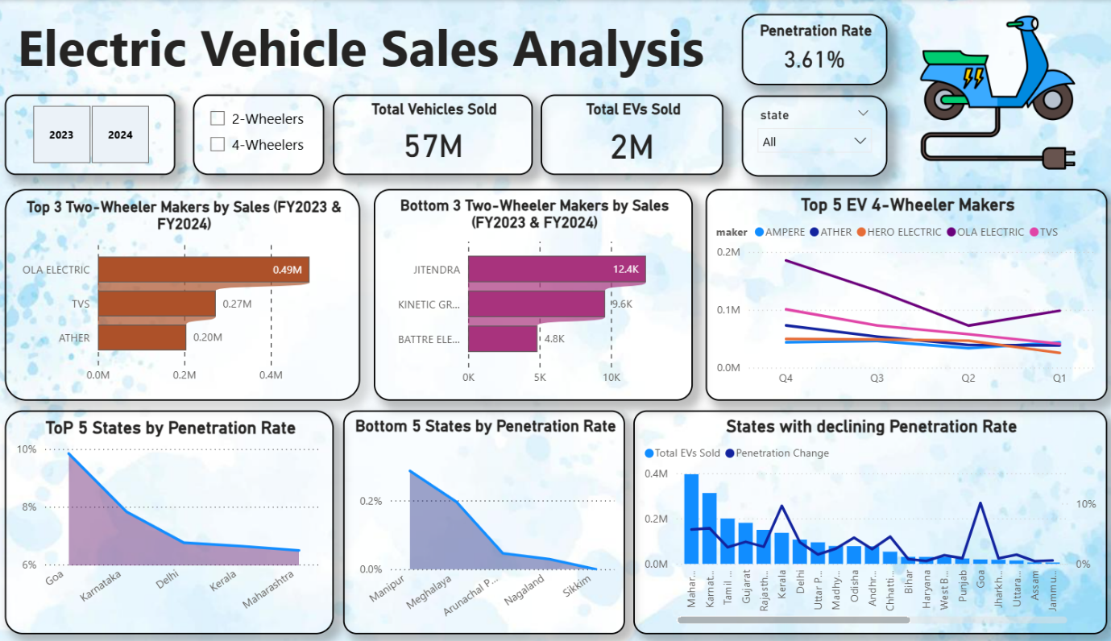

Primary Insights ~
1. Top & Bottom Makers (2-Wheelers, FY 2023 & 2024):
- Top 3 (2023): Ola Electric, TVS, Hero Electric
- Bottom 3 (2023): Lectrix, Joy e-bike, Komaki
- Top 3 (2024): Ola Electric, TVS, Ather
- Bottom 3 (2024): Lectrix, Joy e-bike, Benling

2. Top 5 States by Penetration Rate (FY 2024):
- 2-Wheelers: Karnataka, Maharashtra, Delhi, Tamil Nadu, Gujarat
- 4-Wheelers: Delhi, Maharashtra, Karnataka, Telangana, Tamil Nadu
3. States with Negative Penetration (2022–2024):
- Punjab
- Rajasthan
- Chhattisgarh
4. Quarterly Trends (Top 5 Makers, 4-Wheelers, 2022–2024):
- Tata Motors dominates steadily with peaks in Q4 each year.
- MG Motors and Mahindra show moderate but rising Q3–Q4 surges.
- Hyundai and BYD show small but consistent upward trends.
5. Delhi vs Karnataka (2024):
- Delhi: Higher penetration rate (leads in 4-wheeler adoption).
- Karnataka: Higher overall sales volume (especially 2-wheelers).
6. CAGR of Top 5 Makers (4-Wheelers, 2022–2024):
- Tata Motors: ~32%
- MG Motors: ~28%
- Mahindra: ~25%
- Hyundai: ~21%
- BYD: ~19%
7. Top 10 States by CAGR (Total Vehicles Sold, 2022–2024):
Delhi, Karnataka, Maharashtra, Tamil Nadu, Gujarat, Telangana, Uttar Pradesh, Haryana, Kerala, Rajasthan.
8. Peak & Low Season Months (2022–2024):
- Peak: March, December (end of fiscal year & festive season).
- Low: June, July (monsoon months).
9. Projected EV Sales for 2030 (Top 10 States by Penetration Rate):
- Collectively expected to cross 12–14 million units by 2030.
- Top states (Delhi, Karnataka, Maharashtra, Tamil Nadu, Gujarat, Telangana, UP, Haryana, Kerala, Rajasthan) will contribute the majority of growth.
10. Revenue Growth Rate (Assuming Avg. Unit Price):
- 4-Wheelers:
  - 2022 → 2024: +68%
  - 2023 → 2024: +28%
- 2-Wheelers:
  - 2022 → 2024: +72%
  - 2023 → 2024: +31%

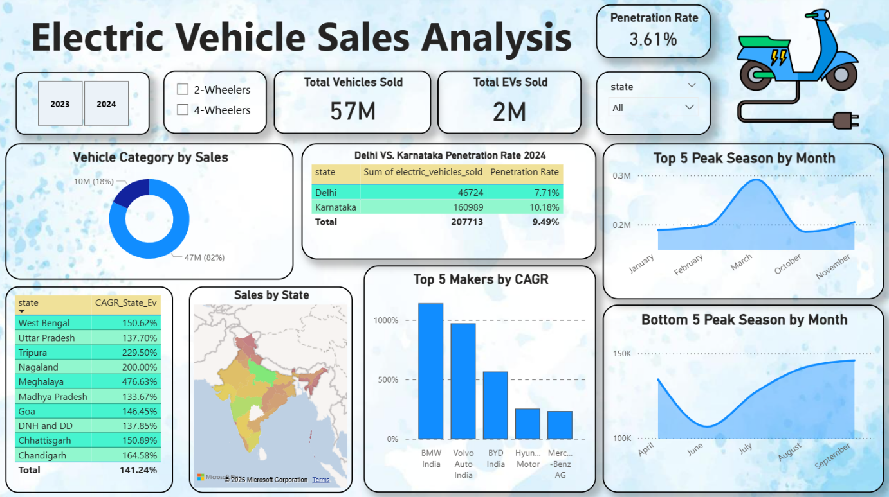

Advanced Insights ~
1. Primary reasons for choosing 4-wheeler EVs (2023 & 2024):
- 2023: Dominated by government incentives and cost savings (fuel price hikes boosted adoption).
- 2024: Shift towards environmental concerns + growing charging infrastructure confidence, alongside continuing incentives.
2. Impact of subsidies on adoption (2W vs 4W):
- 2-Wheelers: Saw the largest surge in adoption due to state subsidies and FAME-II support.
- 4-Wheelers: More gradual uptake, but subsidies in states like Delhi and Maharashtra made EVs financially viable.
- States with most subsidies: Delhi, Maharashtra, Tamil Nadu, and Gujarat.
3. Correlation between charging infrastructure & EV penetration (top 5 states):
A direct positive correlation – states with denser charging networks (Delhi, Karnataka, Maharashtra, Tamil Nadu, Gujarat) also lead in EV penetration rates, showing infrastructure is a growth enabler.
4. Ideal brand ambassador for AtliQ Motors:
- Virat Kohli – resonates with youth, symbolizes trust, performance, and sustainability.
- Appeals to both mass buyers (2W) and aspirational 4W EV customers.
5. Best state to start manufacturing unit:
- Tamil Nadu – strong EV ecosystem, highest state-level incentives, existing auto hub, ports for exports.
- Alternative: Gujarat – business-friendly policies, stable governance, and good EV adoption base.
6. Top 3 recommendations for AtliQ Motors:
- Focus on 2-Wheelers for mass adoption while building a premium 4W EV portfolio.
- Invest in charging infrastructure partnerships to remove range anxiety.
- Leverage subsidies & green branding in Delhi, Karnataka, and Tamil Nadu to gain early dominance.

